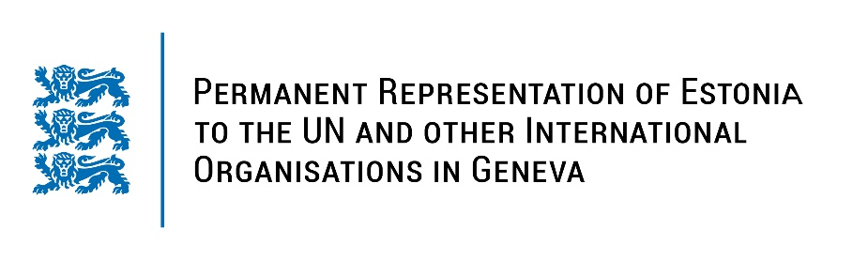
Universal Periodic Review of the Argentine Republic
23 January 2023
Intervention by the delegation of Estonia

Estonia welcomes the delegation of the Argentine Republic to the 42nd UPR session and thanks for the report and the information provided today.

Estonia applauds Argentina for establishing the Ministry for Women, Gender and Diversity in 2019. We also commend Argentina for ensuring legal abortion and for the adoption of the Act on Access to Voluntary Interruption of Pregnancy. Estonia notes with appreciation the positive developments that Argentina has made in its commitments to improve access to public information.

Estonia would like to recommend to Argentina to:
- further improve access to sexual and reproductive health services across the country on equal terms, by ensuring adequate budget, infrastructure, staffing and training;
- continue fighting against gender-based and domestic violence as well as discrimination of women, by adapting the judicial system to the needs of victims and by introducing early detection and reporting mechanisms;
- take steps to ensure the participation and decision-making of indigenous peoples in all matters that concern their rights and adapt relevant legislation.

Estonia wishes the delegation of Argentina a successful review meeting.

I thank you!

