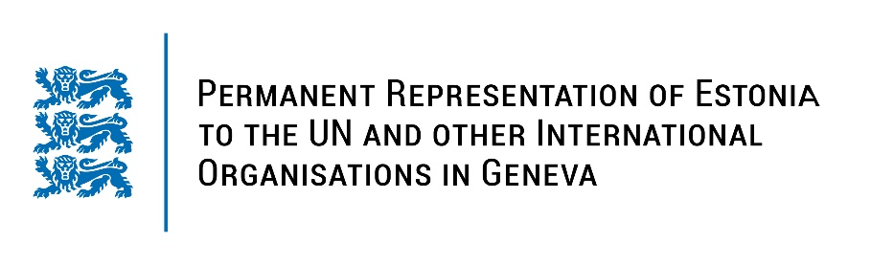
Universal Periodic Review of the Czech Republic
23 January 2023
Intervention by the delegation of Estonia

Estonia welcomes the delegation of the Czech Republic to the 42nd UPR session and thanks for the report and the information provided today.

Estonia appreciates the role of Czechia in promoting human rights and a diversified level of human rights protection across the country.

Estonia commends Czechia for ratifying the Optional Protocol to the Convention on the Rights of Persons with Disabilities. We applaud Czechia for its approach to combatting extremism and prejudiced hatred and for the adoption of detailed Action Plans. Estonia commends Czechia for its activities on promoting gender equality and adopting the Government Strategy for Gender Equality 2021-2030.

Estonia would like to recommend to Czechia to:
- pursue necessary measures to ratify the Istanbul Convention;
- further strengthen the empowerment of women and children, especially the fight against domestic, sexual and gender-based violence;
- implement the measures necessary to respond to all manifestations of child sexual exploitation and abuse, in particular in cyberspace.

Estonia wishes the delegation of Czechia a successful review meeting.

I thank you!

