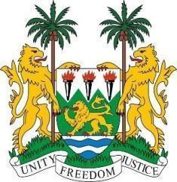

SIERRA LEONE STATEMENT
42nd Session of the Universal Periodic Review
JAPAN
31st January 2023
Sierra Leone welcomes the distinguished delegation of Japan and thanks them for their presentation and continued engagement with human rights mechanisms.
My delegation commends the Government of Japan for its continued financial support to the Office of the High Commissioner for Human Rights and trust that similar support will be extended to the LDC`s Trust Fund.
We welcome the enactment of the Promotion of Human Rights Education and Human Rights Awareness Raising Act (2000) aimed at popularising human rights education at all levels within the Japanese society.
We offer the following recommendations for Japan`s consideration:
- Consider implementing practice direction to address the application of international human rights treaties in Japanese courts.
- Develop implementation measures regarding discrimination and hate speech.
- Consider ratifying the international human rights instruments that it is yet to ratify.

Sierra Leone wishes Japan a successful review.

Thank you, Mr President.

