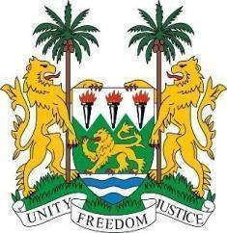
SIERRA LEONE
42nd Session of the Universal Periodic Review

ZAMBIA

30 January 2023

Mr. President,
Sierra Leone welcomes Honourable Minister of Justice H.E. Mulambo Haimbe, SC, MP and the distinguished delegation of Zambia and thanks them for their presentation and its full commitment and engagement with human rights mechanisms.
My delegation commends the Government of Zambia for the provision of the Social Cash Transfer Programme to vulnerable persons that now stand to benefit over one million households in 2022.
We also applaud the government for implementing new policies and guidelines to combat Gender Based Violence, such as the National Gender Policy. We welcome the 8th National Development Plan (2022 – 2026) that absorbs fundamental human rights norms into its work .
We recommend for the consideration of Zambia as follows:
- Take concrete steps to prevent all forms of discriminations, mutilation, deaths and attacks against persons with Albinism and provide them access to healthcare and education.

- Strengthen measures to reduce mortality rates and identify root causes of neonatal mortality and stillbirth, and design programmes for new-born health interventions.

- Consider ratifying the ICRMW (migrant workers convention).

Sierra Leone wishes the sister Republic of Zambia a successful review.

