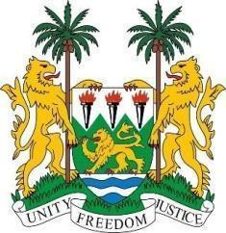
SIERRA LEONE STATEMENT
42nd Session of the Universal Periodic Review
PAKISTAN
30th January 2023
Check against delivery
Mr. President,
Sierra Leone welcomes H.E. Ms. Hina Rabbani Khar, Minister of State for Foreign Affairs and the distinguished delegation of Pakistan and thanks them for their presentation and full cooperation with the human rights mechanisms.
We stood in solidarity with the government and people of Pakistan following last year`s devastating floods. We welcome last month`s donors conference that committed over $9 billion to help Pakistan recover from the floods.
We further welcome both the enactment of a series of legislations aimed at accessing justice, and promoting and protecting women`s rights, and press freedom and the judgement in the case of Mumtaz Bibi v Qasim where it held that marriage below the age of 18years is void ab initio.
We note the provisions of articles 3 and 25 of the constitution and in a spirit of constructive dialogue, makes the following recommendations:
- That the draft National Interfaith Harmony Policy guarantees the practice of minority faiths including the Ahmadiyya Muslims.
- Consider to withdraw its ``declaration`` on CEDAW and ratify its optional protocol.
- Take concrete steps to ensure equal and effective participation of minorities including women, faith-based groups and protect their rights and civil liberties.
- Fully implement the Supreme Court ruling of 19th June 2014 calling for concrete measures to protect members of religious minorities and their place of worship.

Sierra Leone wishes Pakistan a successful review.
I thank you
Mr. President

