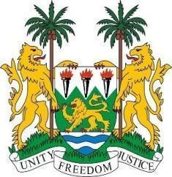
SIERRA LEONE SATEMENT

42nd Session of the Universal Periodic Review

Switzerland

27th January 2023

Mr. President,

Sierra Leone welcomes the distinguished delegation of host state of Switzerland and thanks them for their presentation.

My delegation commends the Swiss Government for its strategic and effective coordination attached to the implementation of its human rights obligations. We note in particular the establishment of both International Human Rights Policy Core Group and the International Human Rights Protection Unit.

We welcome one of the fundamental elements of Swiss democracy; the sacred right of citizens to amend the constitution by means of ``popular initiative``. This speaks volumes of the high degree of pluralism of the Swiss society.

We hereby recommend for the due consideration of Switzerland as follows:

- Provide sufficient funding for the National Human Rights Institution to enable it fulfil its mandates.
- Consider to ratifying the Optional Protocol to the ICCPR and the migrant Workers Convention (ICPRMW) .

- Adopt a comprehensive disability strategy and action plan for implementation of the rights set out in the Convention on the Rights of Persons with Disabilities.

Sierra Leone wishes Switzerland a successful review.

Thank you, Mr President.

