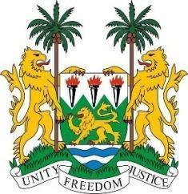
SIERRA LEONE STATEMENT

42nd Session of the Universal Periodic Review

BENIN

26th January 2023

Madam Vice President,

Sierra Leone welcomes the distinguished delegation of Benin and thanks them for their continued engagement with human rights mechanisms.

My delegation commends the Government of Benin for abolishing the death penalty and for ratifying the Treaty on the Prohibition of Nuclear Weapons. We also applaud the government for codifying torture in its criminal code and for developing a national policy in collaboration with the countries of the Gulf of Guinea to combat human trafficking.

We welcome the enactment of Act No. 2021-11 of 20th December 2021 on specific provisions to punish gender-based offences and the protection of women.

We submit the following recommendations for consideration of Benin:

- Reconsider to re-joining the Protocol to the African Charter on Human and People`s Rights on the Establishment of an African Court on Human and Peoples Rights.
- Take concrete measures with a view to protecting persons with albinism from violence, discrimination, abductions and provide them access to education, health and employment.
- Consider to discharge accused persons on trial for offences for which their maximum sentence is beyond the period of their detention.

Sierra Leone wishes Benin a successful review.

Thank you, Madam Vice President.

