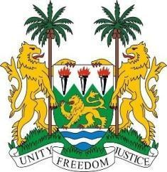
SIERRA LEONE

42nd Session of the Universal Periodic Review

GHANA

24 January 2023

Mr. President,

Sierra Leone welcomes the Hon. Godfrey Yeboah Dame (Attorney-General and Minister of Justice) and the distinguished high-level delegation of Ghana and thanks them for their presentation.

We note that Ghana continues to take progressive steps in the promotion and protection of human rights in particular its lead on Convention against Torture.

We welcome the adoption of both Strategic Plan on Domestic Violence and Victims Support Unit of Ghana Police and the Right to Information Act 2019.

In a constructive spirit, we make the following recommendations:

- Consider to ratify the international treaties and protocols to which Ghana is a signatory.
- Scale up and expand youth-friendly and gender-sensitive programmes on comprehensive sexual and reproductive health and rights.
- Consider to ratify the Second Optional Protocol to the International Convention on Civil and Political Rights.
Sierra Leone wishes Ghana a successful review.

Thank you, Mr President.

