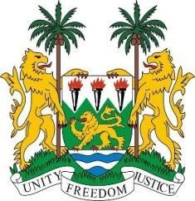
SIERRA LEONE

42nd Session of the Universal Periodic Review

GABON

24 January 2023

Mr. President,

Sierra Leone welcomes Hon. Minister and the distinguished delegation of Gabon and thanks them for their presentation.

My delegation commends the Gabonese government for adopting a strategy to promote women’s rights and reduce gender inequality and for amending its criminal code to further prevent and eliminate violence and discrimination against women.

We also applaud the government for strengthening provisions in its Children’s Code, adding new language that clearly proscribes employing minors under the age of 16.

We recommend for the consideration of the Gabonese government as follows:

- Take concrete measures to reduce existing educational inequalities against vulnerable persons including refugees and IDPs.

- Consider to ratify the ICPRMW.

- Expedite the process of adopting the Anti-Human Trafficking Plan and prosecute perpetrators.

- Establish a legal framework and / or a National Action Plan to prevent and eliminate child and early forced marriage.

Sierra Leone wishes Gabon a successful review.

Thank you, Mr President.

