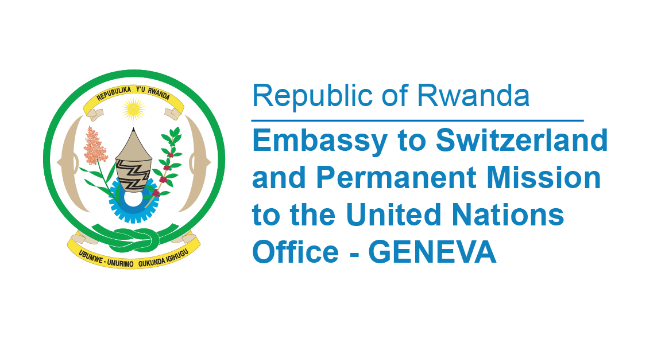

42nd Session of the UPR Working Group
Review of Zambia
30th January 2023 (14.30 – 18.00)
Statement delivered by Marie Chantal RWAKAZINA, Ambassador and Permanent Representative of the Republic of Rwanda
Thank you, Mr. President,
Rwanda welcomes the high delegation of Zambia led by Honourable Mulambo Hiambe, Minister of Justice and thanks them for the presentation of their National Report.
We appreciate Zambia’s review of the legislative framework relating to the right to freedom of expression and peaceful assembly, which led to the amendment of the Electoral Process Act to facilitate voting of persons in lawful custody.
Rwanda commends the launching of 8th National Development Plan 2022-2024 whose theme is “Social Economic Transformation for improved Livelihoods,” and seeks to pursue growth that transforms the livelihood of the people.
Rwanda also notes with appreciation the act of acceding to the Convention on the Prevention and Punishment of the Crime of Genocide in April 2022.
In a spirit of constructive dialogue, Rwanda recommends Zambia the following:
- To consider ratifying the Second Optional Protocol to the International Covenant on Civil and Political Rights; and
- To consider ratifying International Convention on the Protection of the Rights of All Migrant Workers and Members of Their Families.
Rwanda wishes Zambia a successful review.
Thank you

