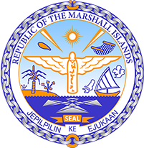

Republic of the Marshall Islands
STATEMENT by Mr. Samuel L. Lanwi Jr., Deputy Permanent Representative
42nd Session, Universal Periodic Review
27 January 2023
Geneva
Switzerland

Check against delivery

Thank you, Mr. Vice President,

The Republic of the Marshall Islands warmly welcomes the Delegation of Switzerland and thanks them for their presentation.

The adverse impacts of climate change affect all of us across the globe not just in the most vulnerable countries but also in developed metropolitan countries such as Switzerland. Climate change effects like the severe melting of Alpine glaciers threaten water supplies and biodiversity, and clearly signals serious consequences for future generations if left unabated.

In the spirit of constructive engagement, we recommend the following:

- Intensify efforts to divest from the fossil fuel sector and strive to set mandatory rules for businesses to report and prevent environmental, climate, and human rights risks;
- Align its NDCs with the Paris Agreement goal of limiting global warming to 1.5 degrees Celsius above pre-industrial levels; and
- Continue to improve the effectiveness of its mechanisms for the protection of migrant workers from exploitation, abuse and harassment.

We wish the delegation every success during its 4th UPR cycle.

Kommol tata and I thank you.

