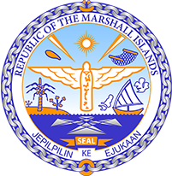

Republic of the Marshall Islands
STATEMENT by Ms. Yi-Hsuan, Wu
42nd Session, Universal Periodic Review
26 January 2023
Geneva
Republic of Korea

Check against delivery

Thank you, Madam Vice-President,

The Republic of the Marshall Islands warmly welcomes the delegation of the Republic of Korea.

We welcome the Republic of Korea’s efforts to protect the rights of women and children, including in its recent legislation and amendments. We also welcome efforts by the Government to move towards the formal abolition of the death penalty. We look forward to seeing the Government continue to pursue these efforts.

In the spirit of constructive engagement, we recommend the following:

- Devise and implement strategies and structural reforms towards ensuring the equal participation of women in public and political life, including their proportional representation in the National Assembly and provincial and local government councils;
- Take concrete steps towards the formal abolition of the death penalty; and
- Align its NDCs with the Paris Agreement goal of limiting global warming to 1.5 degrees Celsius above pre-industrial levels.

We wish the delegation every success during its 4th UPR cycle.

Kommol tata and I thank you.

