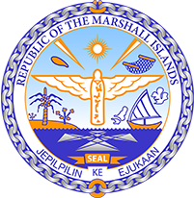

Republic of the Marshall Islands
STATEMENT by Mr. Samuel L. Lanwi Jr., Deputy Permanent Representative
42nd Session, Universal Periodic Review
31 January 2023
Geneva
Japan

Check against delivery

Thank you, Madame Vice President,

The Republic of the Marshall Islands warmly welcomes the Delegation of Japan and thank them sincerely for the presentation of their report.

We are concerned about the adverse impacts of nuclear waste on communities both in Japan and throughout the Pacific. Japan’s acceleration of its timeline for the release of radioactive wastewater into the Pacific ocean poses an extreme environmental and human rights risk. We urge Japan to continue to uphold human rights, including the rights of children and prevention of exposure to hazardous substances.

In the spirit of constructive dialogue, we respectfully recommend the following:

- Halt plans to discharge radioactive wastewater into the Pacific ocean unless the Pacific Island Forum's independent assessment concludes that this is an acceptable measure;
- Provide all of the data requested by the Independent Scientific Experts from the Pacific Island Forum’s independent assessment without delay and ensure that this data is presented in good order;
- Conduct a comprehensive Environmental Impact Assessment; and
- Develop and implement alternatives to the discharge plan that would protect the people and ecosystems in the Pacific ocean from harm caused by radioactive waste products.

We wish the delegation every success during its 4th UPR cycle.

Kommol tata and I thank you.

