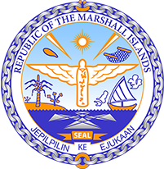

Republic of the Marshall Islands
STATEMENT by Ms. Stephanie Hiromi Spear
42nd Session, Universal Periodic Review
23 January 2023
Geneva
Argentina

Check against delivery

Thank you, Mr. President,

The Republic of the Marshall Islands welcomes the delegation of Argentina and commends its efforts to combat climate change with the adoption of the National Climate Change Adaptation and Mitigation Plan. We also commend the steps taken towards stronger environmental policies.

We are, however, concerned with recent observations of violent confrontations with environmental and human rights defenders and their criminalization, including those defending Indigenous communities and lands.

In the spirit of constructive engagement, we recommend the following:

- Implement human rights based approaches in its environmental and climate change policies, legislation and regulations allowing the comprehensive protection and enjoyment of human rights against the adverse impacts of climate change;
- Adopt a comprehensive policy for the protection of environmental and human rights defenders with strategies to prevent and investigate attacks against them, including those perpetrated by State agents; and
- Continue efforts to align its NDCs with the Paris Agreement goal of limiting global warming to 1.5 degrees Celsius above pre-industrial levels.

We wish the delegation every success during its 4th UPR cycle.

Kommol tata and I thank you.

