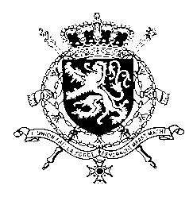
Représentation permanente de la Belgique auprès des Nations Unies et auprès des institutions spécialisées à Genève

WG UPR – Zambia
Belgian intervention
30th January 2023

President,

Belgium welcomes recent progress made by Zambia in protecting and promoting human rights, in particular the adoption of the Penal Code Amendment Bill 2022, resulting in the abolishment of the death penalty and the annulment of the Defamation Act.

In order to achieve even more progress, Belgium would like to recommend Zambia to:

R1. Pursue efforts regarding abolition of the death penalty by ratifying the Second Optional Protocol to the International Covenant on Civil and Political Rights
R2. Amend the 1955 Public Order Act, the Cyber Crimes Act and the Cyber Security Act in order to ensure that the rights to freedom of expression, peaceful assembly and association are respected and protected

R3. Repeal laws criminalizing consensual same-sex conduct between adults and review all legislation to foster equality and prevent discrimination on the basis of sexual orientation or gender identity.

Thank you, President.

