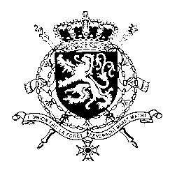
Représentation permanente de la Belgique auprès des Nations Unies et auprès des institutions spécialisées à Genève

WG UPR – Pakistan
Belgian intervention
30 January 2023

President,

Belgium welcomes efforts by the Pakistani government to accelerate the elimination of discrimination against women, such as the adoption of the Enforcement of Women’s Property Rights Act of 2019. However, Belgium is convinced more progress can be achieved and recommends the government of Pakistan to:

R1. Adopt legislation to criminalize all forms of gender-based violence, including domestic violence and marital rape, without exceptions

R2. Adopt a comprehensive strategy to eliminate discriminatory stereotypes and harmful practices, including child and forced marriage, and crimes committed in the name of so-called ‘honour’.

R3. Ratify the International Convention for the Protection of All Persons from Enforced Disappearance.

As a strong opponent of the death penalty, Belgium recommends Pakistan at least to:

R4. Restrict the use of the death penalty to crimes that meet the threshold of “most serious crimes”, in conformity with the International Covenant on Civil and Political Rights.

Thank you, President.

