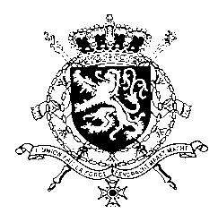
Représentation permanente de la Belgique auprès des Nations Unies et auprès des institutions spécialisées à Genève

WG UPR 42 – Guatemala
Intervention of Belgium
25 January 2023

President,
Belgium welcomes the progress made since the previous UPR of Guatemala, especially the steps in delivering justice in several cases of human rights violations and crimes under international law perpetrated during the internal armed conflict.
Regarding the persistently high rates of violence against women and girls but also the high rates of maternal mortality and early pregnancy, we recommend Guatemala to:
R1. Implement effective and coordinated measures to prevent femicides and violence against women, especially against young women and girls, by providing related action plans with adequate resources and ensuring effective access to justice throughout the country
R2. Implement effective measures to address the high level of pregnancy among girls and adolescents and ensure their effective access to sexual and reproductive health services and education programmes
Belgium is concerned about the ongoing deterioration of the rule of law in Guatemala and therefore recommends to:
R3. Strengthen the independence of the judiciary by ensuring that the appointment of magistrates, judges and prosecutors is done in strict compliance with the principles of transparency, impartiality, and objectivity, and by investigating all threats and attacks against magistrates but also human rights defenders, journalists and indigenous leaders.
Thank you, President

