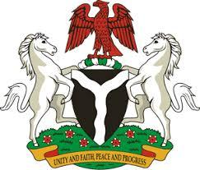

Please check against delivery

HUMAN RIGHTS COUNCIL
42ND SESSION OF THE UPR WORKING GROUP
STATEMENT
BY THE
FEDERAL REPUBLIC OF NIGERIA
ON THE
REVIEW OF SRI LANKA
1ST FEBRUARY, 2023

Mr. President,
Nigeria warmly welcomes the delegation of Sri Lanka to the presentation of its National Report and commends the Government for its unwavering commitment to its international human rights obligations and continued cooperation with human rights mechanisms.
2. In the spirit of constructive engagement, Nigeria wishes to respectfully recommend the following:
- to continue pursuing efforts towards national reconciliation including through national initiatives;
- to strengthen efforts towards national reconciliation while engaging constructively with all stakeholders;
- to promote interfaith dialogue and religious tolerance;
- to pursue measures that strengthen social protection of Households headed by female; and
- to ensure equal access to education for women, children and persons with disabilities.
3. Finally, we wish Sri Lanka a very successful review process.

I thank you Mr. President.

