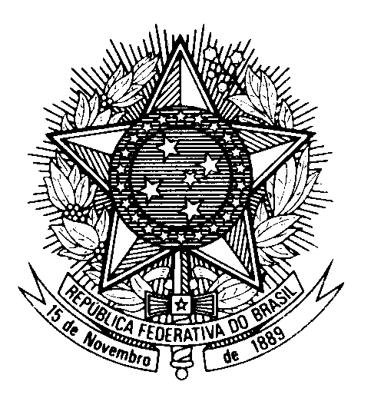

Statement by Ambassador Tovar da Silva Nunes,

Permanent Representative of Brazil to the United Nations Office,

in the review of Sri Lanka, during the 42th session of the Working Group

on the Universal Periodic Review

(Geneva, 1 February 2023)

Brazil welcomes the delegation of Sri Lanka to the UPR.

We commend the continuous efforts aimed at combating poverty and empowering the most vulnerable groups, in particular the implementation of policies to promote gender equality and the empowerment of women.

We remain concerned that capital punishment is still formally part of the Sri Lanka`s Justice system. Likewise, we are concerned with the continuous criminalization of LGBTI individuals.

In a spirit of constructive engagement, Brazil would like to recommend Sri Lanka to:

1. Reform the penal code to formally abolish the death penalty and ratify the second Optional Protocol of the ICCPR; and

2. Review legislation to fully guarantee the right to equality and non-discrimination, particularly concerning decriminalization and non-discrimination on grounds of sexual orientation and gender identity.

We wish Sri Lanka a successful review.

Thank you.

