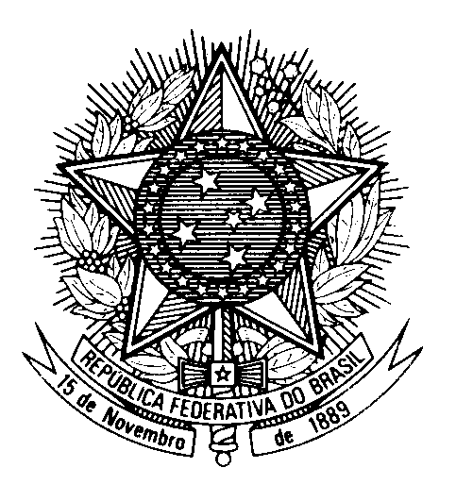
HRC UNIVERSAL PERIODIC REVIEW
JAPAN

(Geneva, January 31st 2023)

STATEMENT OF BRAZIL

Brazil welcomes the delegation of Japan to the UPR.

We commend the ratification of the ILO Convention on the Abolition of Forced Labour and efforts to improve gender equality, including tackling wage differences between men and women.

In a spirit of constructive dialogue, Brazil recommends that Japan:

1) Increase protection of migrants' rights, including by bringing its deportation policy in line with international human rights law and limiting immigration administrative detention;

2) Adopt legislation to ensure and expand free compulsory primary and secondary education for all children residing in Japan, including immigrants, accompanied by public policies on non-discrimination, inclusion and gender equality.

Finally, we urge the Japanese government to adopt a moratorium and abolish the death penalty, as Brazil recommended in 2017.

We wish Japan a successful review.

Thank you.

