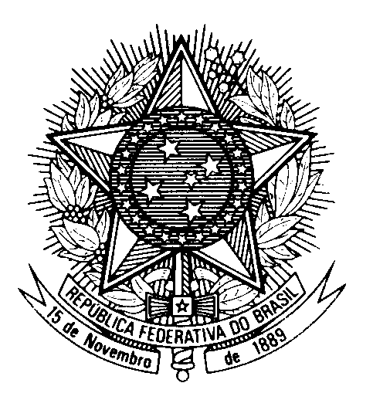
HRC UNIVERSAL PERIODIC REVIEW
ZAMBIA

(Geneva, January 30th 2023)

STATEMENT OF BRAZIL

Brazil welcomes the delegation of Zambia.

We congratulate Zambia on the National Child Policy, the enactment of the Children`s Code Act and the implementation of the Integrated National Registration Information System.

Brazil also commends Zambia for the improvements in the Justice system, including the establishment of specialized gender-based violence courts, new correctional facilities, the incorporation of the Mandela Rules into national legislation with the 2021 Correctional Service Act, and for the abolition of the death penalty last month.

We praise Zambia for expanding economic, social and cultural rights by providing free education and cash transfers, expanding its health care workforce and increasing the health care budget.

In the spirit of constructive dialogue, Brazil recommends that Zambia:

1. ratifies the Second Optional Protocol to the ICCPR; and

2. enacts legislation of access to information, in line with international human rights standards.

We wish Zambia a successful review.

Thank you.

