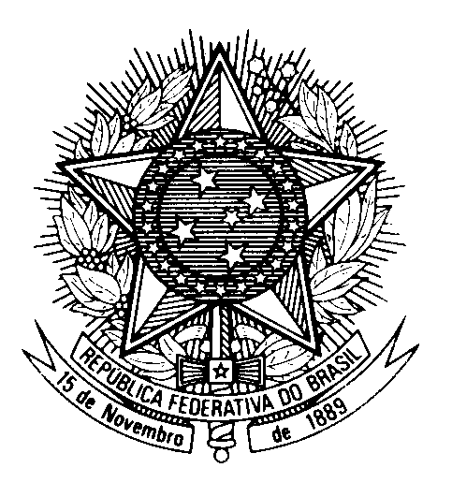
HRC UNIVERSAL PERIODIC REVIEW
PAKISTAN

(Geneva, January 24th 2023)

STATEMENT OF BRAZIL

Brazil welcomes the delegation of Pakistan.

We commend the country`s cooperation with the UN human rights system and the strengthening of the national human rights institutional framework.

We acknowledge the measures implemented by Pakistan towards the empowerment of women.

However, we remain concerned with the high prevalence of violence against women and the many cases of domestic violence. We are also concerned with the increase in the number of enforced disappearances.

In a constructive spirit, Brazil would like to recommend that Pakistan:

1. Redoubles efforts to combat all forms of gender-based violence against women, including domestic violence and marital rape; and
2. Ratifies the International Convention for the Protection of All Persons from Enforced Disappearance.

We wish Pakistan a successful review.

Thank you.

