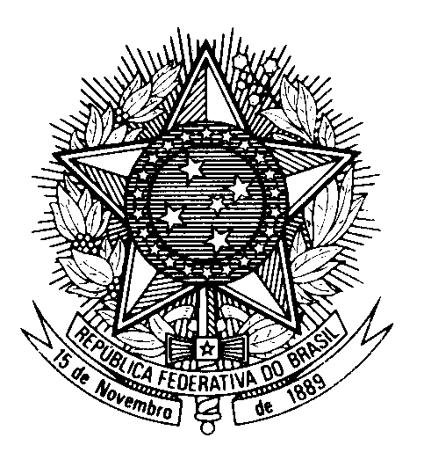

Statement by Ambassador Tovar da Silva Nunes,

Permanent Representative of Brazil to the United Nations Office,

in the review of Republic of Korea, during the 42nd session of the Working Group on the Universal Periodic Review

(Geneva, 26 January 2023)

Brazil welcomes the delegation of the Republic of Korea to the fourth cycle of the UPR.

We commend the Korean government for the approval of the International Convention on Enforced Disappearances.

Brazil encourages the Republic of Korea to continue implementing human rights education programs in schools and invest in capacity-building training of teachers.

With a spirit of constructive dialogue, Brazil recommends the Republic of Korea:
(i) to adopt further concrete measures to combat gender-based violence and gender inequality, including by increasing women`s participation in both private and public sectors; and

(ii) to intensify its efforts to reduce poverty, especially among older persons, by guaranteeing their access to adequate social security, medical care, and by preventing discrimination and abuse.

We also encourage the full implementation of ILO conventions 29, 87, and 98 as well as the ratification of ILO 105.

We wish the Republic of Korea a successful review.

