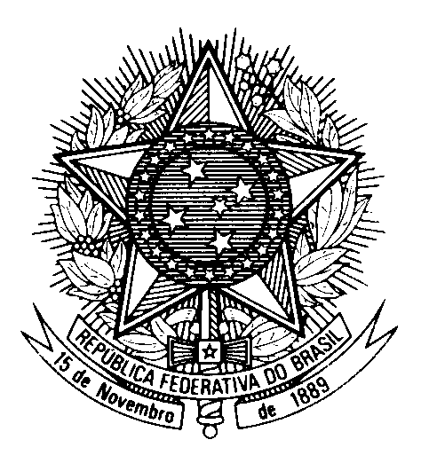
HRC UNIVERSAL PERIODIC REVIEW
GHANA

(Geneva, January 24th 2023)

STATEMENT OF BRAZIL

Brazil welcomes the delegation of Ghana to the UPR.

We congratulate Ghana on the expansion of the access to education and wish a successful implementation of the Free Compulsory Universal Basic Education Policy and the Free Senior High School Policy.

Brazil also commends the Government of Ghana for the efforts and work on improving health care.

In the spirit of constructive dialogue, Brazil recommends:

1. To consider adopting legal and policy measures to protect the LGBT+ community; and

2. To take further measures to eradicate "witch camps" in Northern Ghana, working on raising awareness with traditional leaders, and to promote the reintegration into society of the women found in those camps.

Finally, Brazil urges Ghana to protect civil society organizations dedicated to the LGBT+ community and to human rights in general.

We wish Ghana an excellent review.

Thank you.

