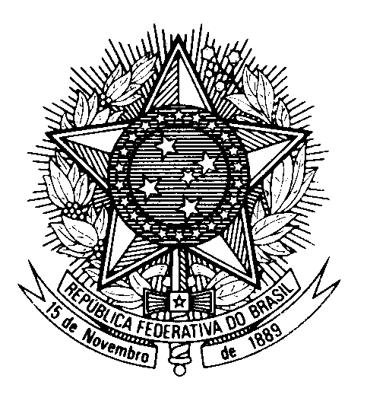

Statement by Ambassador Tovar da Silva Nunes,

Permanent Representative of Brazil to the United Nations Office,

in the review of Czechia, during the 42nd session of the Working Group on the Universal Periodic Review

(Geneva, 23 January 2023)

Brazil welcomes the delegation of Czechia to the UPR.

We congratulate Czechia for having ratified the Optional Protocol to the Convention on the Rights of Persons with Disabilities.

Brazil commends the Czech government for the adoption of the Strategy of Roma Equality, Inclusion and Participation 2021-2030, and encourages its full implementation to bridge the gaps between Roma and the rest of the society in terms of education, housing employment and health.

With a spirit of constructive dialogue, Brazil recommends Czechia:

(i) to enact legislation ensuring equal rights to same-sex couples, including their recognition and access to social security protection; and

(ii) to take effective measures to prevent and combat persistent discrimination, hate speech, prejudices and stereotypes, in particular against Roma, migrants, asylum-seekers, and refugees, online and offline;

Finally, Brazil urges Czechia to redouble its efforts to eradicate violence against women in all its forms.

We wish Czechia a successful review.

