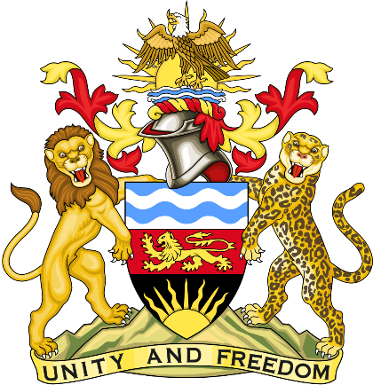

Statement delivered by the Mission of the Republic of Malawi to the United Nations and other International Organisations in Geneva

42nd Session of the Working Group of the Universal Periodic Review

Review of South Korea
January 26th, 2023

Mr. President,

Malawi welcomes South Korea to this review and appreciates the progress the country has made in the promotion and protection of human rights since last review. We particularly note legislation in prevention of human trafficking.
We make the following recommendations.
- Consider ratification of major outstanding international human rights instruments.
- Take steps on alternative service to ensure observance of rights to freedom of thought, belief, conscience and religion.
Thank you, Mr. President.

