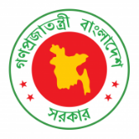
42nd Session of UPR Working Group
Statement by Bangladesh in the Review of Japan under 4th Cycle of UPR
31 January 2022, 0900- 1230hrs.

Thank you, Mr. President,

Bangladesh warmly welcomes the delegation of Japan and thanks them for the presentation of their National Report.

We appreciate measures taken by Japan to promote human rights education at all level. Japan has made significant progress in eliminating discrimination based on disability. We acknowledge Japan’s efforts to eliminate hate speech through the implementation of hate speech elimination act.

In spirit of cooperation, Bangladesh makes the following recommendations to Japan:
One, step up its efforts to implement Basic plan for gender equality to ensure women’s equal participation in public and political life.
Two, Consider establishing an independent national human rights institution in accordance with the Paris Principles.
We wish Japan success in its review.

I thank you.
****

