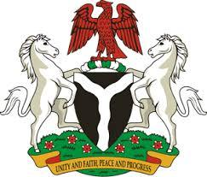

Please check against delivery

HUMAN RIGHTS COUNCIL
42ND SESSION OF THE UPR WORKING GROUP
STATEMENT
BY THE
FEDERAL REPUBLIC OF NIGERIA
ON THE
REVIEW OF JAPAN
31ST JANUARY, 2023

Mr. President,
Nigeria warmly welcomes the delegation of Japan to the presentation of its National Report and commends the Government for its unwavering commitment to its international human rights obligations and continued cooperation with human rights mechanisms.
2. We take positive note of Japan’s efforts in promoting human rights education in all spheres including, in schools, communities and workplaces. Nigeria further commends Japan on the amendment of the Basic Act for Persons with Disabilities, in line with the principles of the Convention on the Rights of Persons with Disabilities (CRPD).
3. In the spirit of constructive dialogue, Nigeria wishes to recommend the following:
- to establish a National Human Rights Institution in accordance with the Paris Principles;
- to enact comprehensive legislation to combat human trafficking, including sexual exploitation of women and girls; and
- to bridge the gender gap in employment and wages.
4. Finally, we wish Japan a very successful review process.

I thank you Mr. President.

