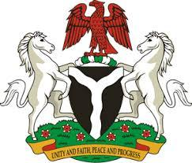

Please check against delivery

HUMAN RIGHTS COUNCIL
42ND SESSION OF THE UPR WORKING GROUP
STATEMENT
BY THE
FEDERAL REPUBLIC OF NIGERIA
ON THE
REVIEW OF ZAMBIA
30TH JANUARY, 2023

Mr. President,
Nigeria warmly welcomes the delegation of the Brotherly nation of Zambia to the presentation of its National Report and commends the Government for its unwavering commitment to its international human rights obligations and continued cooperation with human rights mechanisms.
2. The delegation of Nigeria commends the Government of Zambia on its laudable efforts to implement adopted recommendations of previous cycles. These include implementing the Convention on the Rights of the Child, through the enactment of the Children Code Act No. 12 of 2022 to address the concerns, needs and welfare of children in Zambia. Nigeria further takes positive note of the measures to promote the welfare of Persons living with Albinism.
3. In the spirit of constructive dialogue, Nigeria wishes to make the following recommendations for consideration by the Government of Zambia:
- to consider further positive measures to protect the rights of Persons living with Albinism; and
- to expedite process of enacting appropriate legislation in accordance with the provisions of the Convention Against Torture.
4. In conclusion, we wish Zambia a very successful review process.

I thank you Mr. President.

