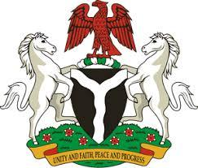

Please check against delivery

HUMAN RIGHTS COUNCIL
42ND SESSION OF THE UPR WORKING GROUP
STATEMENT
BY THE
FEDERAL REPUBLIC OF NIGERIA
ON THE
REVIEW OF ARGENTINA
23RD JANUARY, 2023

Mr. President,
Nigeria warmly welcomes the delegation of Argentina to the presentation of its National Report and commends the Government for its continued cooperation with international human rights mechanisms.
2. Nigeria takes positive note of the concerted efforts by the Government of Argentina to address discrimination, xenophobia and racism, through the National Plan against Discrimination 2021 – 2024, developed by the National Institute to Combat Discrimination, Xenophobia and Racism. We also commend the efforts of the Argentine Government in implementing reforms that has optimized the judicial system in the country.
3. In the spirit of constructive dialogue, Nigeria wishes to make the following recommendations for consideration by the Government of Argentina:
- to expedite the process of appointing an Ombudsperson for the Nation; and
- to continue the laudable efforts to effectively eradicate inequality and discrimination against indigenous people and people of colour.
4. In conclusion, Nigeria wishes Argentina a very successful review process.

I thank you Mr. President.

