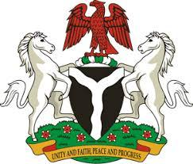

Please check against delivery

HUMAN RIGHTS COUNCIL
42ND SESSION OF THE UPR WORKING GROUP
STATEMENT
BY THE
FEDERAL REPUBLIC OF NIGERIA
ON THE
REVIEW OF PAKISTAN
30TH JANUARY, 2023

Mr. President,
Nigeria warmly welcomes the delegation of the Brotherly nation of Pakistan to the presentation of its UPR National Report and commends the Government for its unwavering commitment to its international human rights obligations and continued cooperation with human rights mechanisms.
2. The delegation of Nigeria takes positive note of the efforts by the Government of Pakistan to promote human rights within its borders, through the enactment of laws on family, women and children, capacity building of national human rights institutions and collaboration with members of civil society amongst others. Nigeria also welcomes the enactment of the Bill on Torture, Custodial Death and Custodian Rape, which inter alia, highlight punishments for the aforementioned, in accordance with the Pakistan Penal Code of 1860.
3. In the spirit of constructive dialogue, Nigeria wishes to recommend the following for consideration by the Government of Pakistan:
- to continue its commitments to upholding human rights and fundamental freedoms of all; and
- to deepen efforts on protection of the rights of all citizens of Pakistan.
4. In conclusion, we wish Pakistan a very successful review process.

I thank you Mr. President.

