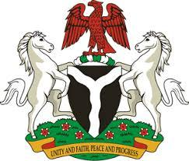

Please check against delivery

HUMAN RIGHTS COUNCIL
42ND SESSION OF THE UPR WORKING GROUP
STATEMENT
BY THE
FEDERAL REPUBLIC OF NIGERIA
ON THE
REVIEW OF SWITZERLAND
27TH JANUARY, 2023

Mr. President,
Nigeria warmly welcomes the delegation of Switzerland to the presentation of its National Report and commends the Government for its unwavering commitment to its international human rights obligations and continued cooperation with human rights mechanisms.
2. We commend the commitment of the Government of Switzerland for the strident efforts demonstrated in the establishment of a National Human Rights Institution. In addition, Nigeria lauds the adoption of the Equality Strategy 2030, which advances the equality between men and women in professional/public life, work-life balance, gender-based violence and discrimination. Indeed, the delegation of Nigeria further takes positive note of the giant strides towards human rights development by Switzerland.
3. In the spirit of constructive dialogue, Nigeria wishes to recommend the following for consideration by the Government of Switzerland:
- to intensify efforts in the elimination of racism and racial discrimination;
- to eliminate gender pay gap, by ensuring parity in wages paid to men and women performing the same functions in same organization.
4. In conclusion, we wish Switzerland a very successful review process.

I thank you Mr. President.

