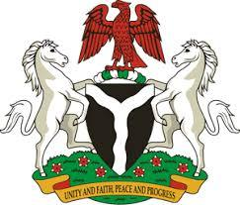

Please check against delivery

HUMAN RIGHTS COUNCIL
42ND SESSION OF THE UPR WORKING GROUP
STATEMENT
BY THE
FEDERAL REPUBLIC OF NIGERIA
ON THE
REVIEW OF THE REPUBLIC OF BENIN

26TH JANUARY, 2023

Mr. President,
Nigeria warmly welcomes the delegation of the Brotherly Republic of Benin to the presentation of its National Report and commends the Government for its continued cooperation with international human rights mechanisms.
2. Nigeria further commends the Government of Benin for the efforts exerted to strengthen its general legal framework, as it works on its law’s compliance with international human rights law. In addition, Nigeria takes positive note of the progress made in ensuring access to justice, including the adoption of a law on the modernization of the justice system, and establishment of new courts as well as the digitalization of procedures.
3. In the spirit of constructive dialogue, Nigeria wishes to make the following recommendations for the consideration of the Government of Benin:
- to expedite the process for adopting the National policy document on combating trafficking in persons and an action plan on its implementation; and
- to adopt a law establishing a National Mechanism for the prevention of torture, in line with the Optional Protocol to the Convention against Torture and Other Cruel, Inhuman or Degrading Treatment or Punishment.
4. Finally, Nigeria wishes Benin a very successful review process.
I thank you, Mr. President.

