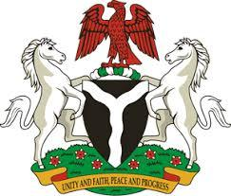

Please check against delivery

HUMAN RIGHTS COUNCIL
42ND SESSION OF THE UPR WORKING GROUP
STATEMENT
BY THE
FEDERAL REPUBLIC OF NIGERIA
ON THE
REVIEW OF THE REPUBLIC OF GHANA
24TH JANUARY, 2023

Mr. President,
Nigeria warmly welcomes the delegation of the Brotherly Republic of Ghana to the presentation of its National Report and commends the Government for its unwavering commitment to its international human rights obligations and continued cooperation with human rights mechanisms.
2. We commend the Government of Ghana for the concerted efforts to implement adopted recommendations of previous cycles. These include: fostering good governance and combatting corruption, through, inter alia, the enactment of the Right to information Act. Nigeria further takes positive note of the Ghana’s efforts to combat Female Genital Mutilation, which has contributed to an overall decline in the practice across the country. In addition, the Government’s establishment of a fully equipped one-stop facility in Accra, to provide holistic response to cases of domestic violence is a truly noble and laudable action.
3. In the spirit of constructive dialogue, Nigeria wishes to encourage the Government of Ghana to continue in its efforts to swiftly enact the Code of Conduct for Public Officers Bill.
4. In conclusion, we wish Ghana a very successful review process.

I thank you Mr. President.

