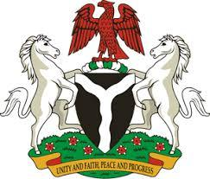

Please check against delivery

HUMAN RIGHTS COUNCIL
42ND SESSION OF THE UPR WORKING GROUP
STATEMENT
BY THE
FEDERAL REPUBLIC OF NIGERIA
ON THE
REVIEW OF GABON

24TH JANUARY, 2023

Mr. President,
Nigeria warmly welcomes the delegation of Gabon to the presentation of its National Report and commends the Government for its continued cooperation with international human rights mechanisms.
2. Nigeria further commends the Government of Gabon for the efforts exerted to strengthen legislation on violence against women, by adopting the amended Criminal Code and Civil Code. We also take positive note of the establishment of an effective birth registration system in Gabon, which can act as vital proof of one’s age and protect children against Child, Early and Forced Marriage.
3. In the spirit of constructive engagement, Nigeria wishes to make the following recommendations for the consideration of the Government of Gabon:
- to develop a strategy to sensitize citizens (especially in rural communities) /create more awareness on the perils of child early and forced marriage; and
- to adopt the Children’s code, which inter alia raises the minimum age for marriage of girls to 18
4. Finally, Nigeria wishes Gabon a very successful review process.
I thank you, Mr. President

