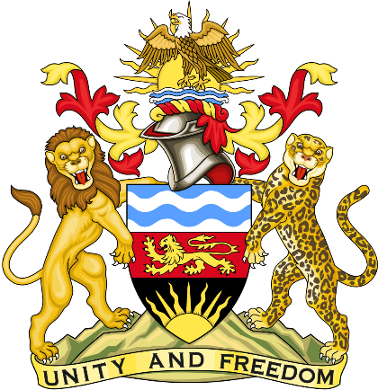

Statement delivered by the Mission of the Republic of Malawi to the United Nations and other International Organisations in Geneva

42nd Session of the Working Group of the Universal Periodic Review

Review of Pakistan
January 27th, 2023

Mr. President,

Malawi welcomes Pakistan to this review and appreciates the progress the country has made in the promotion and protection of human rights since last review, despite the challenges posed by covid and devastating floods. We particularly note the invitation to four special procedures since 2020.
We make the following recommendations.
- Continue to take concrete steps to address prevalence of gender-based violence.
- Conclude the drafting and adoption of National Interfaith Harmony Policy.
Thank you, Mr. President.

