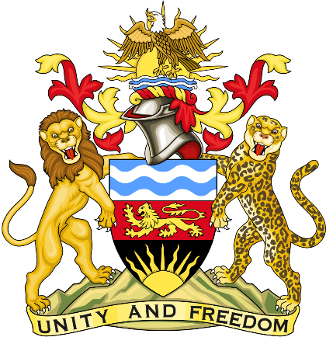

Statement delivered by the Mission of the Republic of Malawi to the United Nations and other International Organisations in Geneva

42nd Session of the Working Group of the Universal Periodic Review

Review of Zambia
January 30th, 2023

Mr. President,

Malawi welcomes our sister Republic, Zambia to this review and appreciates the progress the country has made in the promotion and protection of human rights since last review. We particularly note the accession to the Genocide Convention.
We make the following recommendations.
- Progressively ratify outstanding international human rights instruments
- Continue to take all measures to protect children from all forms of exploitation
Thank you, Mr. President.

