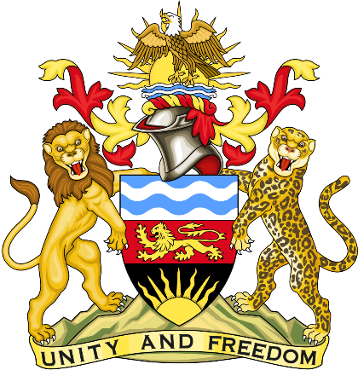

Statement delivered by the Mission of the Republic of Malawi to the United Nations and other International Organisations in Geneva

42nd Session of the Working Group of the Universal Periodic Review

Review of Switzerland
January 27th, 2023

Mr. President,

Malawi welcomes Switzerland to this review and appreciates the progress the country has made in the promotion and protection of human rights since last review. We particularly note the ratification of the Istanbul Convention.
We make the following recommendations.
- Continue to take concrete steps on the implementation of the Paris Climate Agreement.
- Establish an independent mechanism to investigate cases of police abuse, especially when racially motivated.
Thank you, Mr. President.

