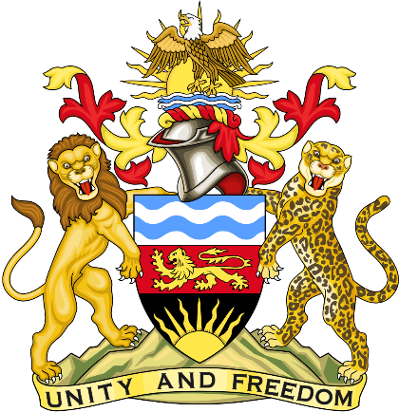

Statement delivered by the Mission of the Republic of Malawi to the United Nations and other International Organisations in Geneva

42nd Session of the Working Group of the Universal Periodic Review

Review of Benin
January 26th, 2023

Mr. President,

Malawi welcomes Benin to this review and appreciates the progress the country has made in the promotion and protection of human rights since last review. We particularly note the ratification of various international human rights instruments.
We make the following recommendations.
- Consider re-joining the Protocol the African Charter on Human and Peoples’ Rights on the Establishment of an African Court on Human Peoples’ Rights.
- Take all measures to protect children from all forms of exploitation
- Take all necessary measures to ensure continued access to education by girls.
Thank you, Mr. President.

