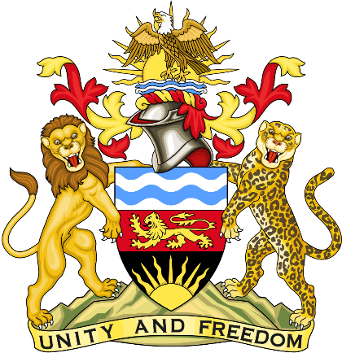

Statement delivered by the Mission of the Republic of Malawi to the United Nations and other International Organisations in Geneva

42nd Session of the Working Group of the Universal Periodic Review

Review of GHANA
January 24th, 2023

Mr. President,

Malawi welcomes Ghana to this review and appreciates the progress the country has made in the promotion and protection of human rights since last review. We particularly note the legislative and institutional measures taken to end child trafficking and abduction.
We make the following recommendations.
- Continue to work with traditional and faith leaders to end harmful cultural norms/practices.
- Ensure the continued freedom of the press and protection of journalists and media practitioner.
- Take all measures to protect children from all forms of violence and exploitation Thank you, Mr. President.

