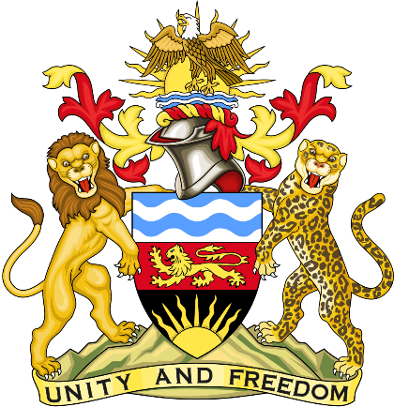

Statement delivered by the Mission of the Republic of Malawi to the United Nations and other International Organisations in Geneva

42nd Session of the Working Group of the Universal Periodic Review

Review of Gabon
January 24th, 2023

Mr. President,

Malawi welcomes Gabon to this review and appreciates the progress the country has made in the promotion and protection of human rights since last review. We particularly note the adoption of the Strategy to Promote Women’s Rights and Reduce Gender Inequality, with specific measures in areas of education, health, family, law, politics, and the economy.
We make the following recommendations.
- Ensure observance of rights of people in detention such as access to adequate food, healthcare, and decent conditions.
- Promote freedom of assembly
- Enhance access to clean water and sanitation in schools
- Consider raising the age of marriage to 18 for both boys and girls
Thank you, Mr. President.

