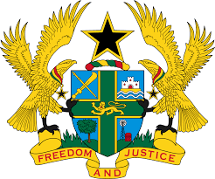
STATEMENT BY GHANA DELIVERED BY H.E EMMANUEL ANTWI, AMBASSADOR AND PERMANENT REPRESENTATIVE, DURING THE 42ND SESSION OF THE UPR WORKING GROUP ON TUESDAY, 31ST JANUARY 2023

UNIVERSAL PERIODIC REVIEW OF JAPAN

Thank you Mr President,
Ghana warmly welcomes the distinguished delegation of Japan to the 4th Cycle of the UPR Working Group and we thank them for the presentation of their national report.

My delegation welcomes strategic measures adopted by Japan in sensitizing its citizens on human rights. The Basic Plan on Human Rights Education and Human Rights Awareness-Raising approved by the Cabinet in 2002 as well as the human rights training offered to its civil servants is laudable.

We also commend the Government of Japan for drafting the Fifth Basic Plan for Gender Equality and further urges that Japan allocates sufficient resources for its effective implementation.

In the spirit of constructive dialogue, Ghana recommends that Japan:

- Strengthens efforts to address the issue of discrimination and hate speech, particularity against the minority in the society; and to also
- Intensify efforts to address child trafficking and ensure perpetrators are held accountable.
We wish Japan every success with the review process.

I thank you.

