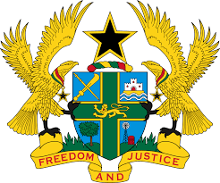
STATEMENT BY GHANA DELIVERED BY H.E EMMANUEL ANTWI, AMBASSADOR AND PERMANENT REPRESENTATIVE, DURING THE 42ND SESSION OF THE UPR WORKING GROUP ON MONDAY, 30TH JANUARY 2023

UNIVERSAL PERIODIC REVIEW OF ZAMBIA

Thank you Mr President,

Ghana extends a warm welcome to the distinguished delegation of Zambia and thanks them for the presentation of their national report.

We note with satisfaction the adoption of a National Strategy on Financial Education (2019-2024). We also note the adoption of various policies to combat gender-based violence against women and girls, the National Strategy on Ending Child Marriage in Zambia (2016-2021) as well as other strategic measures adopted in protecting the rights of children. Ghana further welcomes the introduction of the National Health Scheme to enhance access of health services in Zambia.

To further advance respect for human rights and fundamental freedoms in Zambia, Ghana recommends that Zambia:

- Intensifies efforts to ratify the Optional Protocol to the UNCAT and Optional Protocol to the Convention on the Rights of Persons with Disabilities; and also
- Intensify efforts to adopt the National Plan to combat trafficking in persons.
Ghana wishes Zambia a successful review.

I thank you.

