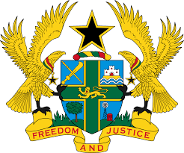
STATEMENT BY GHANA DELIVERED BY H.E EMMANUEL ANTWI, AMBASSADOR AND PERMANENT REPRESENTATIVE, DURING THE 42ND SESSION OF THE UPR WORKING GROUP ON FRIDAY, 27TH JANUARY 2023

UNIVERSAL PERIODIC REVIEW OF SWITZERLAND

Thank you Mr President,

Ghana welcomes the delegation of Switzerland to the 4th Cycle of the UPR Working Group and we thank them for the presentation of their national report.

We acknowledge the establishment of the International Human Rights Policy Core under the leadership of the Federal Department of Foreign Affairs and applaud the adoption of the Foreign Policy Strategy (2020–2023) and Equality Strategy 2030. My delegation also commend Switzerland for the adoption of a bill in 2021 establishing a national human rights institution to replace the Swiss Centre of Expertise in Human Rights.

In the spirit of constructive dialogue, Ghana recommends that Switzerland:
- Intensifies efforts to ratify the International Convention on the Protection of the Rights of all Migrant Workers and Members of Their Families (ICRMW); and also
- Intensify its efforts in addressing issues of gender inequalities, particularly gender pay gap and pension age gap.
My delegation wishes Switzerland every success with the review process.

I thank you.

