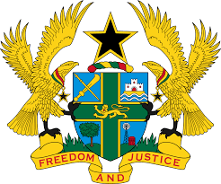
STATEMENT BY GHANA DELIVERED BY H.E EMMANUEL ANTWI, AMBASSADOR AND PERMANENT REPRESENTATIVE, DURING THE 42ND SESSION OF THE UPR WORKING GROUP ON THURSDAY, 26TH JANUARY 2023

UNIVERSAL PERIODIC REVIEW OF REPUBLIC OF KOREA

Thank you Mr President,
Ghana extends a warm welcome to the distinguished delegation of the Republic of Korea to the 4th UPR Cycle.

Ghana lauds the Republic of Korea for its continuous efforts in upholding respect for human rights and fundamental freedoms in the country. The inclusion of human rights education as a subject in the school curriculum in 2018 and the adoption of the second Gender Equality Basic Plan (2018-2022) to eliminate discrimination against women and to promote gender equality are commendable.

My delegation welcomes the decision of the Republic of Korea to withdraw its reservation to Article 25(e) of the Convention on the Rights of Persons with
Disabilities (CRPD). We further commend the Government for the strategic measures adopted to improve human rights in the military service.

Ghana makes the following two recommendations for the consideration of the Republic of Korea:
- Intensify ongoing processes leading up to the ratification of the OP-CAT; and

- Continue efforts to ensure the protection of the rights and promotion of welfare of the migrant workers.

Ghana wishes the Republic of Korea success with the review.

I thank you.

