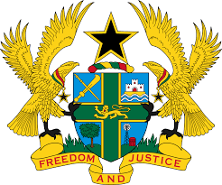
STATEMENT BY GHANA DELIVERED BY H.E EMMANUEL ANTWI, AMBASSADOR AND PERMANENT REPRESENTATIVE, DURING THE 42ND SESSION OF THE UPR WORKING GROUP ON THURSDAY, 26TH JANUARY 2023

UNIVERSAL PERIODIC REVIEW OF BENIN

Thank you Mr President,

Ghana extends a warm welcome to the distinguished delegation of Benin to the 4th UPR Cycle. We thank them for the presentation of the comprehensive national report.

Ghana welcomes Benin’s ratification of the Optional Protocol to the Convention on the Elimination of All Forms of Discrimination against Women in 2019, the Optional Protocol to the Convention on the Rights of the Child on a communications procedure also in 2019 and the International Convention on the Protection of the Rights of All Migrant Workers and Members of Their Families in 2018.

We also note with satisfaction the adoption of the National Development Plan (2018–2025), Act 2020-08 on the Modernization of the Justice System, and the launch of Human Rights Commission in 2019, aimed at strengthening respect for human rights and fundamental freedoms in the country.

In conclusion, Ghana urges the government of Benin to continue its efforts in ensuring the implementation of Act No.2003-3 to combat Female Genital Mutilation (FGM) in the country.

Ghana wishes Benin a successful review process.

I thank you.

