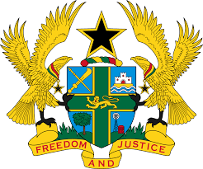
STATEMENT BY GHANA DELIVERED BY H.E EMMANUEL ANTWI, AMBASSADOR AND PERMANENT REPRESENTATIVE, DURING THE 42ND SESSION OF THE UPR WORKING GROUP ON TUESDAY, 24TH JANUARY 2023

UNIVERSAL PERIODIC REVIEW OF GABON

Thank you Mr President,

Ghana warmly welcomes the distinguished delegation of Gabon to the 4th Cycle of the UPR Working Group and we thank them for the presentation of their national report.

My delegation applauds Gabon for adopting new laws and regulations following the third cycle review, especially laws on the elimination of violence against women and labour Code. We also commend Gabon for reforming several institutions, including the Gabon Elections Centre, the High Communications Authority, the National Observatory for Women’s Rights and the newly built women’s facility at Libreville Central Prison.

We also welcome the constitutional reforms in Gabon which has led to major progress in the promotion and protecting of human rights in Gabon.

To further consolidate democracy and respect for rule of law in Gabon, Ghana recommends that Gabon:

- Ratifies the International Convention on the Protection of the Rights of All Migrant Workers and Members of Their Families; and secondly

- Accelerates its efforts towards adopting comprehensive strategies to combat issues of child marriage in Gabon.
Ghana wishes Gabon a successful review process.

I thank you.

