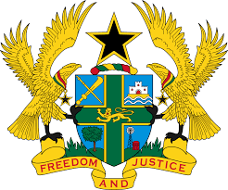
STATEMENT BY GHANA DELIVERED BY H.E EMMANUEL ANTWI, AMBASSADOR AND PERMANENT REPRESENTATIVE, DURING THE 42ND SESSION OF THE UPR WORKING GROUP ON MONDAY, 23RD JANUARY 2023

UNIVERSAL PERIODIC REVIEW OF ARGENTINA

Thank you Mr President,

Ghana extends a warm welcome to the delegation of Argentina to their fourth UPR process.

My delegation welcomes the actions taken by Argentina towards the promotion and protection of human rights. Of note is the establishment of the National Committee for the Prevention of Torture in 2017, the Ministry for Women, Gender and Diversity in 2019 and the re-establishment of the Ministry of Health.

Ghana also commends Argentina for the adoption of the National Plan for Combating Gender-Based Violence (2020–2022) and urges the Government to take further necessary action to establish a comprehensive strategic plan to prevent and eradicate discrimination and racism against indigenous women, including providing access to justice mechanisms. We further commend the Government of Argentina for the adoption of measures geared toward safeguarding freedom of expression, association and assembly in Argentina.
While applauding the Government for the significant measures adopted for the protection and promotion of the rights of women, Ghana recommends that Argentina strengthens its efforts to prevent and combat all forms of gender-based violence.
Ghana wishes Argentina every success with the review.

I thank you.

