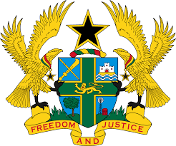

STATEMENT BY GHANA DELIVERED BY H.E EMMANUEL ANTWI, AMBASSADOR AND PERMANENT REPRESENTATIVE, DURING THE 42ND SESSION OF THE UPR WORKING GROUP ON MONDAY, 23RD JANUARY 2023

UNIVERSAL PERIODIC REVIEW OF CZECH REPUBLIC

Thank you Mr President,
Ghana warmly welcomes the distinguished delegation of the Czech Republic to the 4th Cycle of the UPR Working Group and we thank them for the presentation of their national report.

My delegation notes with satisfaction the adoption of the first National Action Plan for business and human rights and the Government Strategy for Gender Equality for 2021-2030. We further commend Czech Republic for the adoption of the National Strategy to Protect Children’s Rights for 2021-2029 as well as a Prison Policy Concept to improve prisons conditions in the country.
While we welcome the adoption of the Policy Concept of Combating Extremism and
Prejudiced Hatred (2021-2026), Ghana urges the Government to continue its efforts to effectively implement domestic and international laws which ensures that promoters of discrimination and hate crime against minority groups, including the Roma minority are brought to justice.
My delegation further urges Czech Republic to continue to take appropriate measures to ensure that Roma children fully realize their right to education in an inclusive environment.
Ghana wishes Czech Republic success with the UPR outcome.
I thank you.

