Jamhuuriyadda Federaalka Soomaaliya  Ergada Joogtada Soomaliyeed ee Qaramada Midoobey ee Geneva | 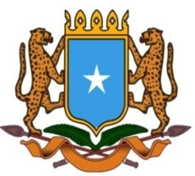 | جمهورية الصوما ل الفيدرالية  البعثة الدائمة لجمهورية الصومال بمكتب الأمم المتحدة بجنيف وبالوكالات المتخصصة بسويسرا

Permanent Mission of the Federal Republic of Somalia to the United Nations Office at Geneva and other International Organizations in Switzerland

Check Against Delivery
Statement by the Delegations of Somalia,
Mr. Abdikadir Mohamed Hussein, First Secretary
at the Review of Zambia, during the 42th Session of the UPR Working Group on Tuesday, 30 January, 2023 from 02:30 PM to 06:00PM, in the Room XX of the Palais des Nations in Geneva, Speaker Number 58, Time: 1 minute and 15 seconds.
Thank you Mr. President,

Somalia thanks the delegation of the Republic of Zambia for the comprehensive national Report and the update provided today.

Somalia commends the positive steps taken by Zambia in implementing the recommendations of the previous cycle and the progress achieved in the field of human rights in particular the improvement made in the national legal system, including the domestication of the provisions of the Convention on the rights of persons with disabilities.

As a constructive contribution to this Universal Periodic Review, my delegation would like to share the following three recommendations:
1. Enact legislation to facilitate access to information
2. Implement recommendations made in the mission report to Zambia by the Special Rapporteur on Persons with Disabilities.
3. Strengthen capacity of the Zambia Agency for Persons with Disabilities

Somalia would like to conclude by wishing to the distinguished delegation of Zambia a successful outcome in this review. I Thank you Mr. President.

